Experiment 5 – Introduction to DML

Objective
- Learn SQL DML commands specially the use of select query, joins and aggregate functions

Exercise1: Practice select command
Login to your own database (lab/<password> on local host) that you created in Lab3 and practice the following Select commands. Please also analyze the query and the results it is bringing and write a statement about what the query is returning on a piece of paper.

- SELECT particular columns from a Table

General syntax:
SELECT <list of columns> FROM <table name>

Example:
Select fname, lname, salary, bdate
From employee

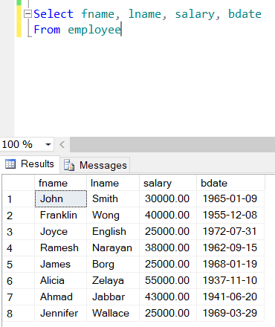

- Select specific rows from a table

General Syntax:
SELECT <* or list of columns>
FROM <table name>
WHERE <condition>

Example:
Select fname, lname, salary, bdate
From employee
Where salary >25000

- Use of order by

General Syntax:
SELECT <* or list of columns>
FROM <table name>
WHERE <condition>
ORDER BY <list of columns>

Example:
Select fname, lname, salary, bdate
From employee
Where salary >25000
Order by salary desc, fname

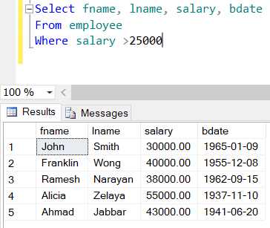

- Use of DISTINCT

Example:
Select distinct salary
From employee

- Use of built in functions

Example:
Select datediff(yy, bdate,GETDATE())age,
fname from employee

- Use of like and between and null comparisons

Examples:
select fname, Lname, salary, bdate
from employee
where bdate between '01-Jan-1960' and '31-Dec-1969'
and lname like 'S%'

select fname, Lname, salary, bdate
from employee
where super_ssn is null

select fname, Lname, salary, bdate
from employee
where super_ssn is not null

Exercise2: Practice select command from multiple tables using inner and outer joins

- INNER JOIN: This join only returns rows when there is at least one match in both the tables on which the JOIN is being applied.

Example:
select e.fname, e.Lname, d.Dname
from employee e inner join department d on e.Dno=d.Dnumber
order by d.Dname, e.fname

- OUTER JOIN:
There are three different Outer Join methods:

- LEFT OUTER JOIN
This join returns all the rows from the left table in conjunction with the matching rows from the right table. If there are no columns matching in the right table, it returns NULL values

Example:
select e.fname, e.Lname, d.dependent_name
from employee e left outer join dependent d on e.ssn=d.essn
order by e.fname, e.lname

- RIGHT OUTER JOIN
This join returns all the rows from the right table in conjunction with the matching rows from the left table. If there are no columns matching in the left table, it returns NULL values.

Example:
select e.fname, e.Lname, d.dependent_name
from dependent d right outer join employee e on e.ssn=d.essn
order by e.fname, e.lname

- FULL OUTER JOIN
This join returns all the rows from the right as well as left table

Example:
First let us insert a department which doesn’t have a manager yet
insert into department(Dname, dnumber) values ('Accounts', 10)

select e.fname, e.Lname, d.dName
from department d full outer join employee e on e.ssn=d.Mgr_ssn
order by e.fname, e.lname

Exercise3: Practice select command using SQL Aggregate functions
- SQL Aggregate functions
Aggregate functions perform a calculation on a set of values and return a single value. These functions are frequently used with the GROUP BY clause of the SELECT statement.
- AVG() - Returns the average of the values in a group. Null values are ignored.
- COUNT() - Returns the number of items in a group. This function always returns an int data type value
- MAX() - Returns the maximum value in the expression.
- MIN() - Returns the minimum value in the expression.
- SUM() - Returns the sum of all the values in the expression. SUM can be used on numeric columns only and it ignores all the NULL values.

General Syntax:
SELECT <list of columns>, <aggregate functions>
FROM <table(s)>
WHERE <condition>
GROUP BY <column(s)>
HAVING < condition based on aggregate function>

Example:
select COUNT(*) NumberOfEmployee, AVG(salary) CompanyAverage, MAX(salary)CompanyMax, MIN(salary)CompanyMin,
SUM(salary) CompanySum
from employee

select d.dname, COUNT(*) DepartmentEmps, SUM(salary) DepartmentSum
from employee e, department d
where e.Dno=d.Dnumber
group by d.dname

select d.dname, COUNT(*) DepartmentEmps, SUM(salary) DepartmentSum
from employee e, department d
where e.Dno=d.Dnumber
group by d.dname
having COUNT(*)>1 and SUM(salary)>125000

Note the old syntax used for joining tables in last two queries, rewrite them using new syntax.

EXERCISE 4:
Using your own database, please run the lab5.sql file and write an SQL statement along with output to answer each of the following queries (it might be helpful if you draw the relational model for the given SQL script first):

- List the names and addresses of all guests who are from London, alphabetically ordered by guest name.
select g.guestname, g.guestaddress
from guest g
where g.guestaddress like '%London'
order by g.guestname

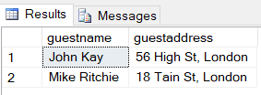

- Display the names of all the guests who have not provided any end date for their reservations.
select g.guestname
from guest g inner join booking b on g.guestno = b.guestno
where b.dateto is null

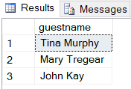

- Display the name and city of the hotels where guest’s from London are staying. The list should not contain any hotel more than once.
select distinct h.hotelname, h.city
from hotel h inner join room r on h.hotelno = r.hotelno
inner join booking b on r.hotelno = b.hotelno
inner join guest g on b.guestno = g.guestno
where g.guestaddress like '%London'

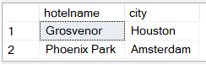
- Display the average room price of the hotels situated in London.
select avg(r.price) avgPrice
from room r inner join hotel h on r.hotelno = h.hotelno
where h.city = 'London'

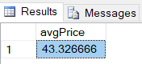

- Display the most expensive double, single and family room respectively (across hotels).
select r.type, max(r.price) maxPrice
from room r
where r.type = 'double'
group by r.type

select r.type, max(r.price) maxPrice
from room r
where r.type = 'single'
group by r.type

select r.type, max(r.price) maxPrice
from room r
where r.type = 'family'
group by r.type

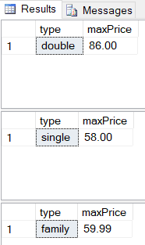

- Display the names of all the hotels along with the number of rooms present in each of them.
select h.hotelname, count(*) noOfRooms
from hotel h inner join room r on h.hotelno = r.hotelno
group by hotelname

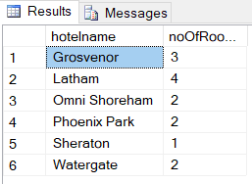

- Display hotel name and city name along with distinct number of room types available in each of them.
select h.hotelname, h.city, count(*) familyCount
from hotel h inner join room r on h.hotelno = r.hotelno
where r.type = 'family'
group by h.hotelname, h.city

select h.hotelname, h.city, count(*) singleCount
from hotel h inner join room r on h.hotelno = r.hotelno
where r.type = 'single'
group by h.hotelname, h.city

select h.hotelname, h.city, count(*) doubleCount
from hotel h inner join room r on h.hotelno = r.hotelno
where r.type = 'double'
group by h.hotelname, h.city

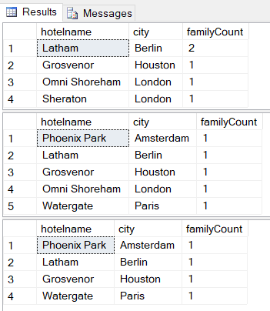

- Display a sorted list of hotel names along with the date for which a room was booked in the hotel. Please note null should be displayed booking date if the hotel has never been reserved by anyone.
select h.hotelname, b.datefrom
from hotel h inner join room r on h.hotelno = r.hotelno
left outer join booking b on r.hotelno = b.hotelno
order by h.hotelname

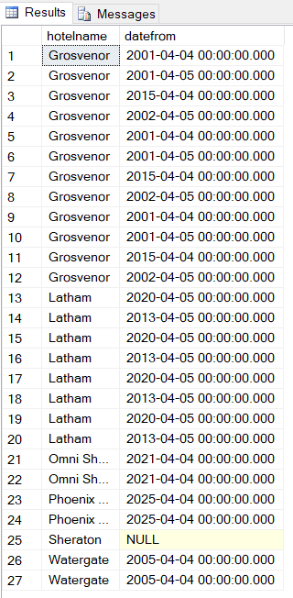

Post Lab
For the same hotel reservation database write SQL statement along with output to answer following queries:
- Display the HotelName and RoomNo which was reserved in the year 2001 and 2002, also display the Guest No who reserved the room at the time.

select h.hotelname, b.roomno, b.guestno, year(b.datefrom) year
from hotel h inner join booking b on h.hotelno = b.hotelno
where year(b.datefrom) = '2001' or year(b.datefrom) = '2002'

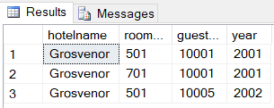

- Display the price of the “Family” type room in all hotels along with the HotelNames, HotelNo, RoomNo. NULL should be shown if a hotel doesn’t have a “Family” type room.
select h.hotelname, h.hotelno, r.roomno, r.type, r.price
from hotel h left outer join room r
on h.hotelno = r.hotelno and r.type = 'family'

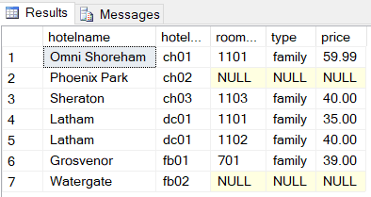

- Give the number of hotels present in each city.
select h.city, count(*) hotels
from hotel h
group by h.city

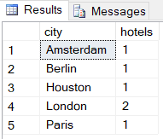

- What is the total revenue generated from all double rooms?
select sum(r.price) totalrevenue
from room r
where r.type = 'double'

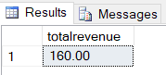

- How many different guests have made bookings till May, 2015?
select count(distinct b.guestno) guests
from booking b
where b.dateto <= '2015-05-01'

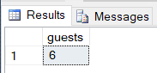

- Display the price and city name of the cheapest hotel rooms available in each city.

select min(r.price) minPrice, h.city
from room r inner join hotel h
on r.hotelno = h.hotelno
group by h.city

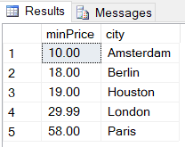
- Display the name(s) of the guest(s) who have reserved two or more than two rooms in a hotel.
select g.guestname, count(b.roomno) rooms
from guest g inner join booking b
on g.guestno = b.guestno
group by g.guestname
having count(b.roomno) > 1

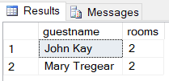

- Display the name, city of all the hotels along with the number of reservations it has, in descending order.
select h.hotelname, h.city, count(distinct b.datefrom) reservations
from hotel h inner join room r
on h.hotelno = r.hotelno inner join booking b
on r.hotelno = b.hotelno
group by h.hotelname, h.city
order by reservations desc

